|  |  |
| --- | --- |
| Project Title | FIX USED REFRACTORY BRICKS AT LINE 5 ROOM D |
| Document No | ACC/REP01/JULY2022 |
| Contractor Name | AL AHLIA CONTRACTING CO. W.L.L. |
| Contractor Project Manager/contact details | RANGEETH RAVINDRAN (870810855)  MOB NO :-38307847 |
| Contractor HSE Officer/contact details | SHINAS P K (950546119) MOB NO:-33156741 |
| Alba Responsible /contact details | SHUAIB AL AALI(17837540) |
| Purchase Order Number | 45260661 |

|  |  |  |  |  |
| --- | --- | --- | --- | --- |
| REV: 00 | Prepared by | Initial Approval | Final Review | Final Approval |
| Date | 04/08/2022 | 05/08/2022 |  |  |
| Name | SHINAS P K | RANGEETH RAVINDRAN | SHUAIB AL AALI |  |
| Designation | Contractor’s HSE Officer | Contractor’s Project Manager | Alba Responsible | SHE Coordinator |

Contents

1. Project Information 3
   1. Scope of work 3
   2. Location 3
   3. Project Schedule 4
   4. Contractor Organization Chart 4
2. Monthly Construction Activities 5
3. Safety, Health and Environment Monitoring Records 10
   1. Project Leading and Lagging Indicators 10
   2. Details of Incidents 11
   3. Key update on Safety, Health, Environment and Fire 11
   4. Waste Record 11
   5. Waste Water 12
   6. Spills Response and Contaminated Land 12
   7. Mock Drill Records on Fire, Safety, Health, Environment 12
   8. Training Record on Safety, Health and Environment 13
   9. Photos of SHE and Construction Activities 13
4. Attachments 18
   1. Monthly Site Inspection form completed (to including photos) 18
   2. Temporary site establishment inspection completed (if any) 18

# Project Information

## Scope of work

#### The scope of work is to pave interlock in the Room D area. All activities of Excavation, manual loading and interlock fixing is done for this. All the work is executed in accordance with Health, Safety & Environmental Action Plan.

## Location

#### Room D

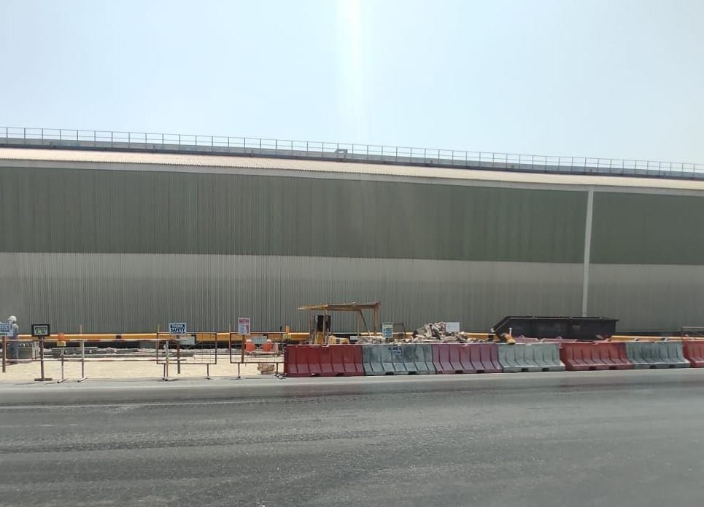

## Project Schedule

|  |  |  |
| --- | --- | --- |
| **Sl no:** | **Date** | **Activity** |
| 1 | 25-07-2022 | Unloading the interlock bricks |
| 2 | 26-07-2022 | Commenced removal of the adhesives from the interlock bricks and  stacked properly |
| 3 | 27-07-2022 | Excavation commenced |
| 4 | 31-07-2022 | Curb stone fixing |

## Contractor Organization Chart

MANAGER O N RUDRAN

PROJECT ENGINEER

RANGEETH RAVINDRAN

HSE OFFICER SHINAS P K

SITE SUPERVISOR APPUSE K J

SITE ENGINEER

SABAREESH RAVEENDRAN

# Monthly Construction Activities

* 1. Activity 1

Date: 25/07/2022

**Unloading the interlock bricks**

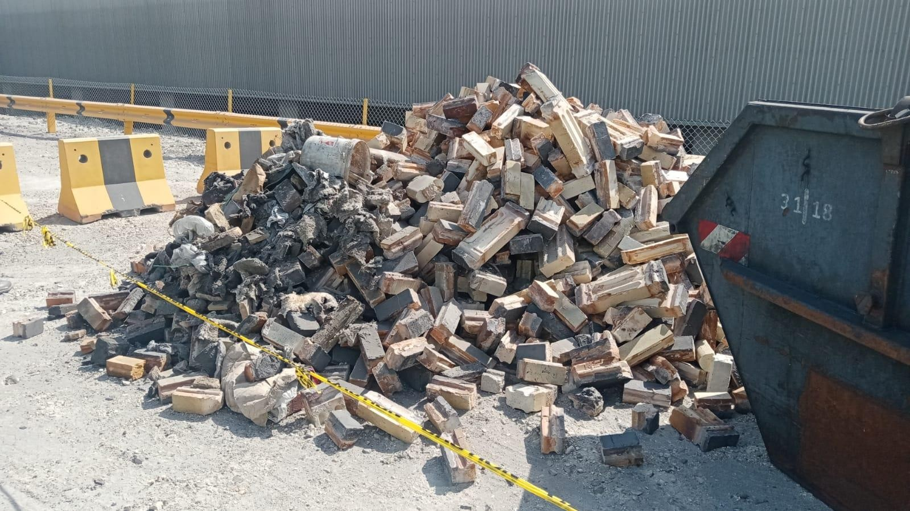

**2.1Activity 2**

Date:26-07-2022

**Commenced removal of the adhesives from the interlock bricks and stacked properly**

Removal of adhesive at our temporary Shelter

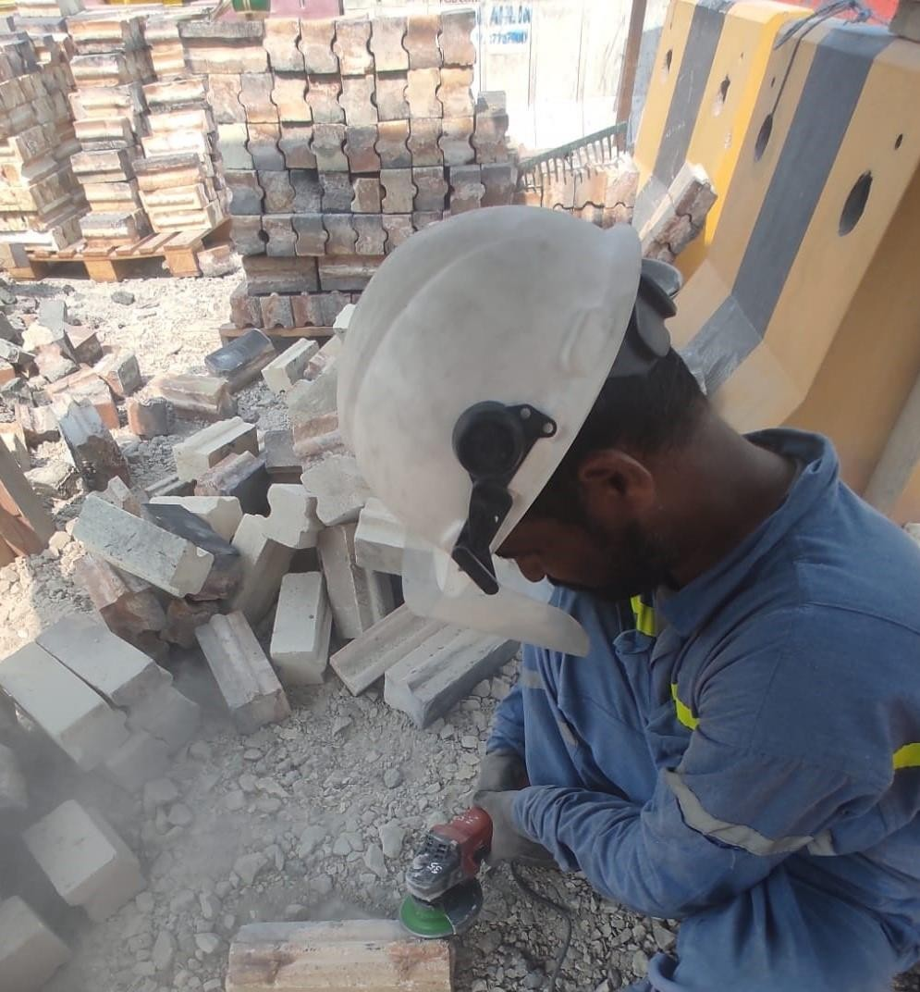

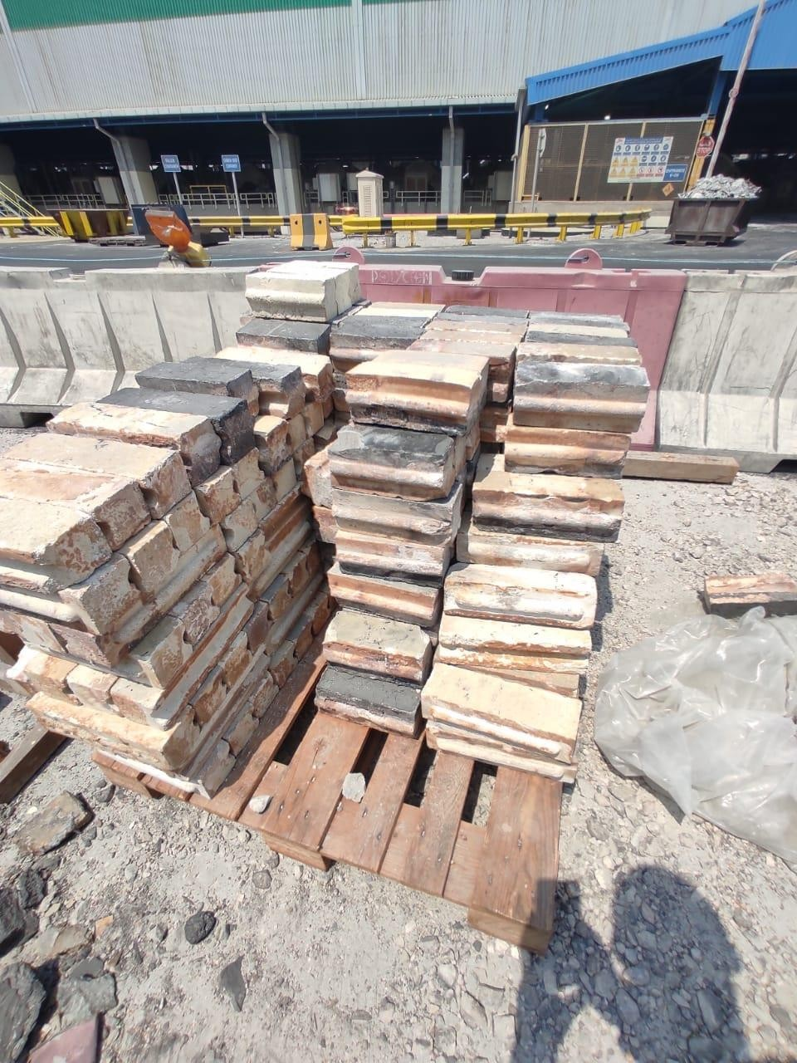

Date :27-07-2022

**Excavation commenced**

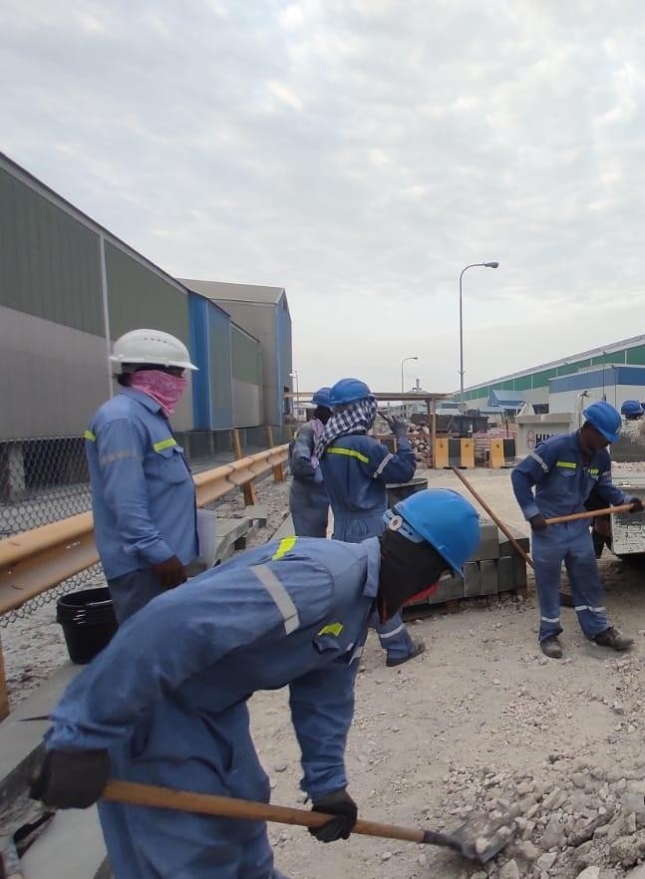

**2.3Activity 4**

Date:31-08-2022

**Kerb stone fixing**

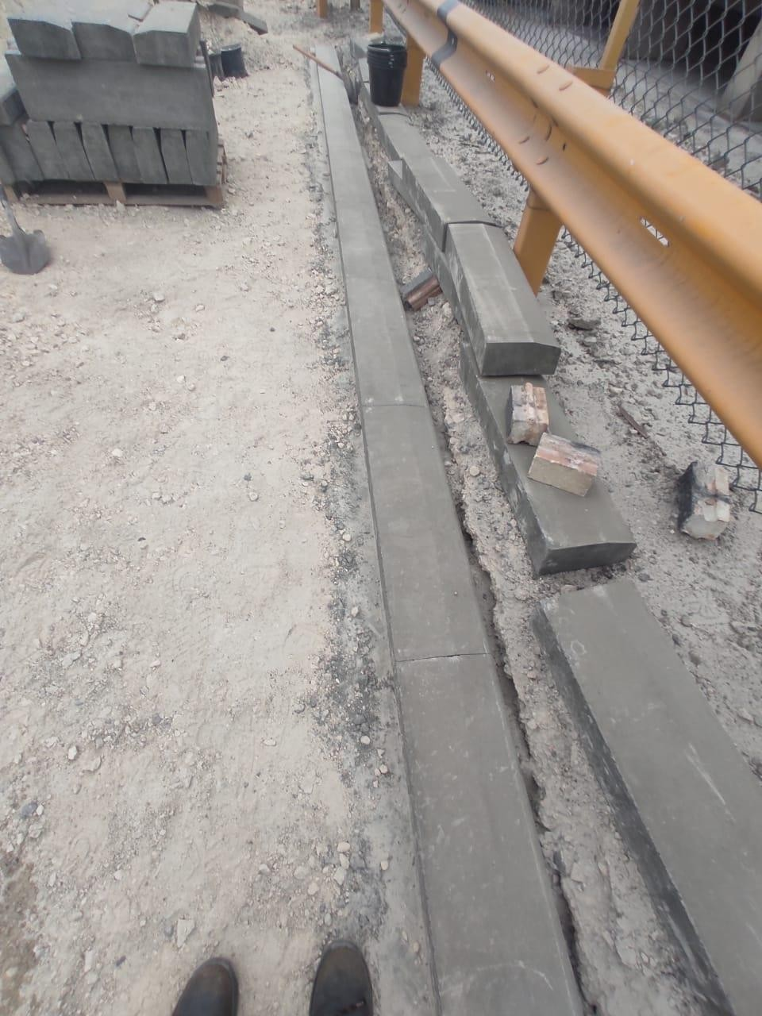

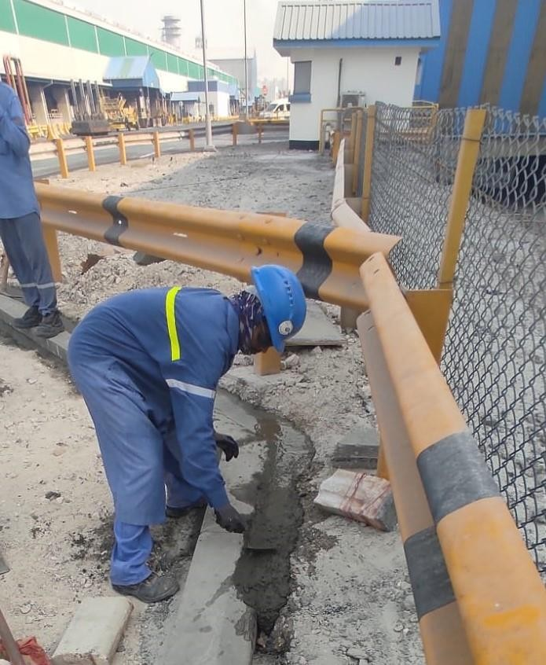

# Safety, Health and Environment Monitoring Records

## Project Leading and Lagging Indicators

|  |  |  |
| --- | --- | --- |
| **Lagging Indicators** | **Monthly** | **Inception to Date** |
| Work hours | 252 | 252 |
| Work hours without LTI | 252 | 252 |
| Lost Time Injury | 0 | 0 |
| Restricted Work Injury | 0 | 0 |
| Medical Treatment Injury | 0 | 0 |
| Recordable Injury* | 0 | 0 |
| First Aid Injury | 0 | 0 |
| LTI Frequency Rate ∞ | 0 | 0 |

|  |  |  |
| --- | --- | --- |
| Recordable Injury Frequency Rate ∞ | 0 | 0 |
| Near Miss Recorded | 0 | 0 |
| High Potential Near Miss Recorded | 0 | 0 |
| Vehicle Incident | 0 | 0 |
| Property Damage | 0 | 0 |
| Environmental Incident | 0 | 0 |
| Fire | 0 | 0 |

* Recordable Injury = Lost Time Injury + Restricted Work Injury + Medical Treatment Injury

∞ Frequency Rate = Number of injuries per 200,000 hours worked

|  |  |  |  |
| --- | --- | --- | --- |
| **No.** | **Leading KPI** | **Monthly** | **Inception to date** |
| 1 | Number of Monthly HSE Meeting | 1 | 1 |
| 2 | Number of weekly site HSE inspections | 1 | 1 |
| 3 | Number of weekly tools/Equipment inspections | 1 | 1 |
| 4 | Number of employee received project induction | 7 | 7 |
| 5 | Number of weekly toolbox talks | 5 | 5 |
| 6 | Number of HSE walk-downs by project Management | 1 | 1 |
| 7 | Number of site observations | 1 | 1 |
| 8 | % of HSE corrective actions vs observation | 100% |  |
| 9 | % of training completed vs planned | 90% |  |
| 10 | HSE Training (Man-hours) | 0 | 2 |
| 11 | % of Mock drill plan compliance | NILL |  |
|  | Number of Average manpower | 7 | 7 |

## Details of Incidents

#### Nil

## Key update on Safety, Health, Environment and Fire

#### Daily tool box talk is taken before the work. We just summarize the details of the work, related hazards that can occur during the work and its preventive measures. Since this work contained many manual handling processes, we made a small session for detailing the procedure of manual handling.

#### Also we made a session about WBGT and the amount of water to be consumed by an individual according to the temperature and work

## Waste Record

|  |  |  |  |  |  |
| --- | --- | --- | --- | --- | --- |
| **#** | **Type of Waste** | **Description of the Material** | **Quantity of Waste (Kg)** | **Transferred by Approved Waste Handler**  **(Yes or No)** | **Destination Name of Landfill/ Recycle/ Incineration facilities (Provide Tracing Evidence) and photos** |
| **1** | Recyclable | Excavated material | 1 load | Yes | Asker landfills |
| **2** | Hazardous |  |  |  |  |

|  |  |  |  |  |  |
| --- | --- | --- | --- | --- | --- |
| **3** | Disposable |  |  |  |  |
| **4** | Incineration |  |  |  |  |
|  | **Total** |  |  |  |  |

## Waste Water

|  |  |  |  |  |
| --- | --- | --- | --- | --- |
| **#** | **Type of Waste** | **Quantity of Wastewater Transferred to STP (KL)** | **Transferred by Approved Waste Handler**  **(Yes or No)** | **Destination – Name of Sewage Treatment Plant** |
| **1** | NIL |  |  |  |
|  | **Total** |  |  |  |

## Spills Response and Contaminated Land

|  |  |  |  |  |  |
| --- | --- | --- | --- | --- | --- |
| **#** | **Spillage Event Explanation** | **Date of Spillage Event** | **Quantity of Hazardous Waste Stored at site (Kg)** | **Quantity of Hazardous Waste Transferred to Landfill (Kg)** | **Name of Landfill facilities** |
| **1** | Nil | Nil | Nil | Nil | Nil |
|  | **Total** | |  |  |  |

## Mock Drill Records on Fire, Safety, Health, Environment

|  |  |  |  |
| --- | --- | --- | --- |
| **Mock Drills No.** | **NIL** | **Date** |  |
| **Emergency Type** |  | | |
| **Location** |  | | |
| **Company** |  | | |
| **Scenario** |  | | |
| **Observations** |  | | |
| **Photos** |  |  | |

## Training Record on Safety, Health and Environment

|  |  |  |  |  |  |
| --- | --- | --- | --- | --- | --- |
| **Monthly** | | | | | |
| **Sl. No.** | **Trainings Course** | **Duration** | **Hours** | **Number of Attendees** | **Total Attendees** |
| **1** | Nil |  |  |  |  |
| **2** | Nil |  |  |  |  |
|  | **TOTAL** |  |  |  |  |

|  |  |  |  |  |  |
| --- | --- | --- | --- | --- | --- |
| **Inception to Date** | | | | | |
| **Sl. No.** | **Trainings Course** | **Duration** | **Hours** | **Number of Attendees** | **Total Attendees** |
| **1** | Nil |  |  |  |  |
|  |  |  |  |  |  |
|  | **TOTAL** |  |  |  |  |

## Photos of SHE and Construction Activities

### Talk on WBGT

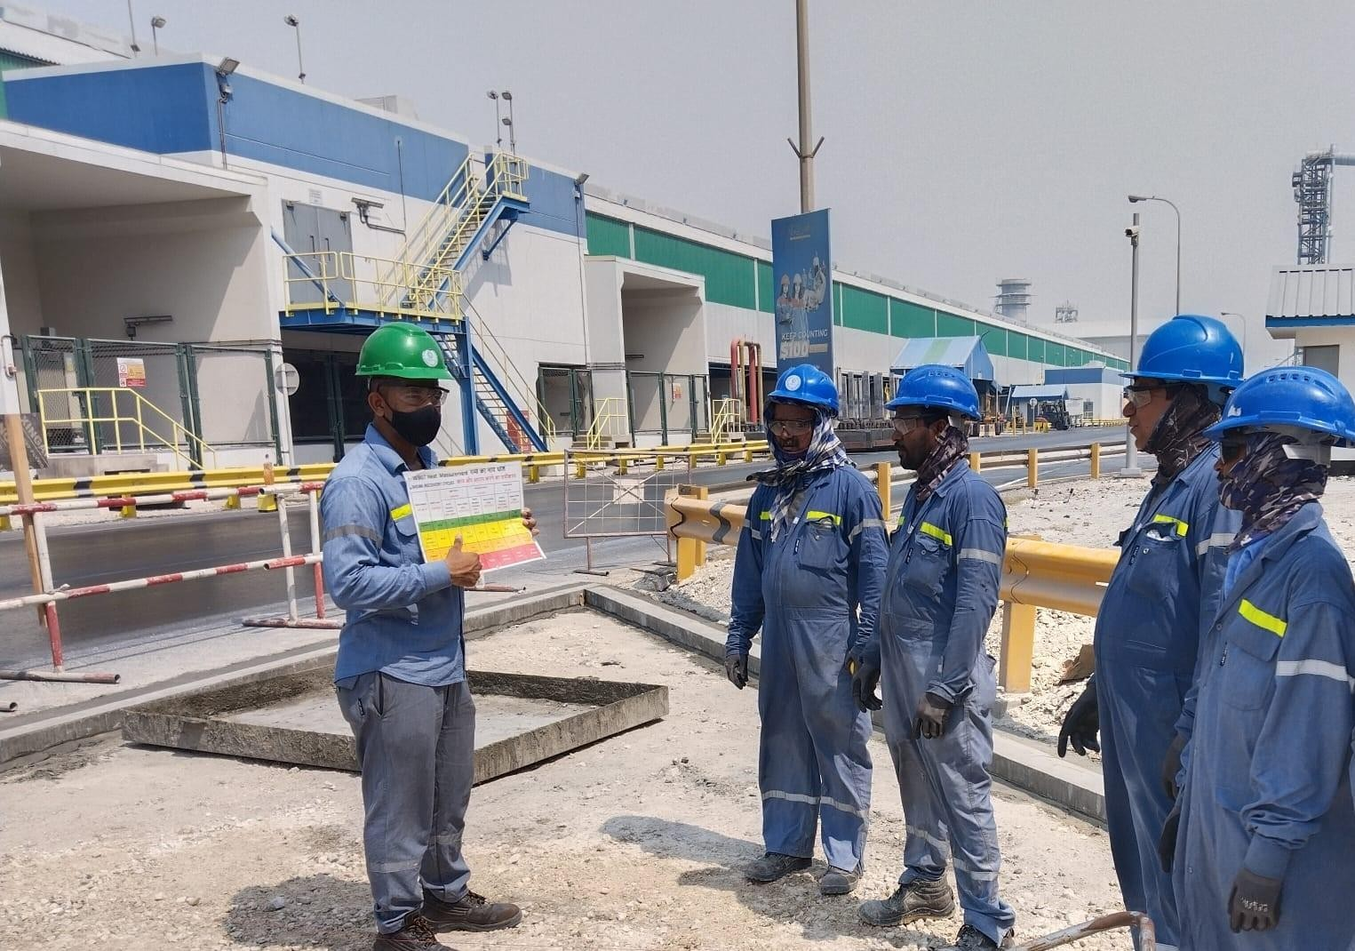

### Safety sign boards as part of safety awareness

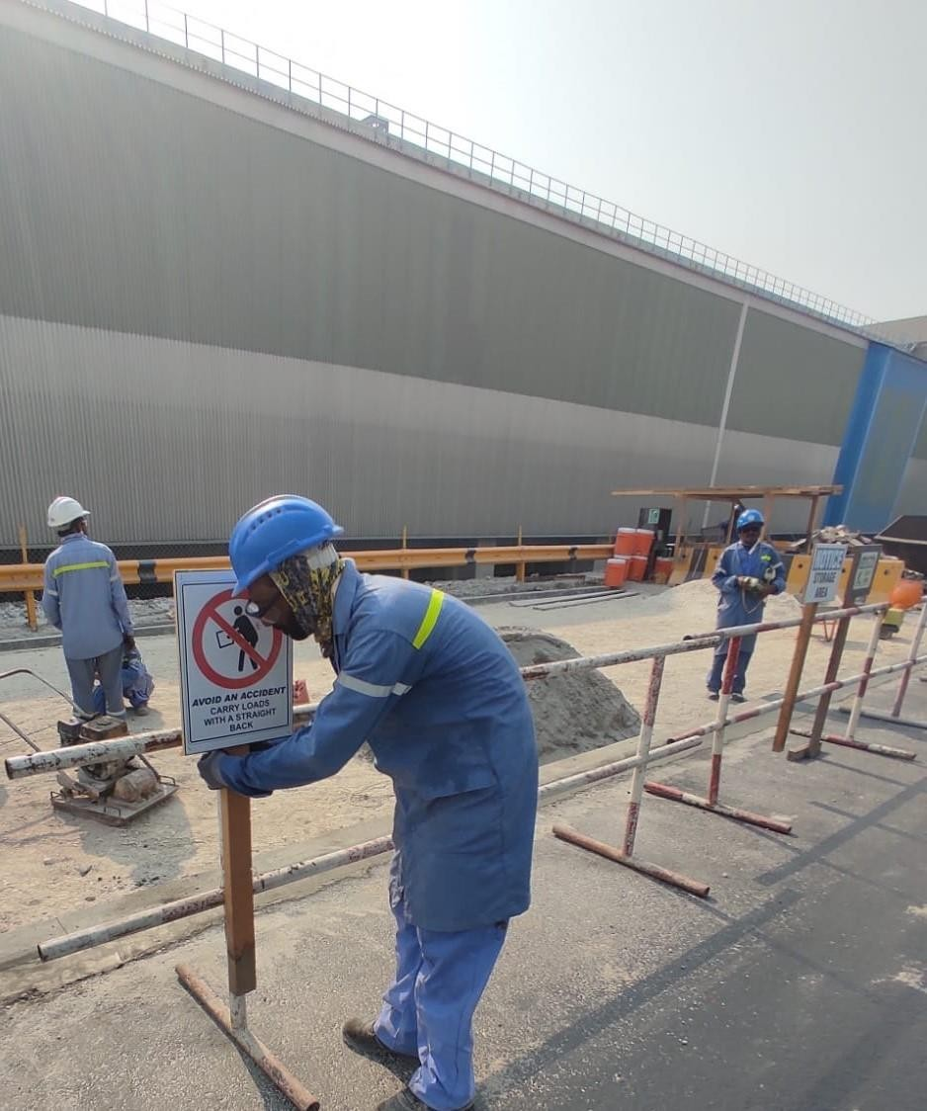

##### 

### Setting and safe guarding the area by sign boards and barrications

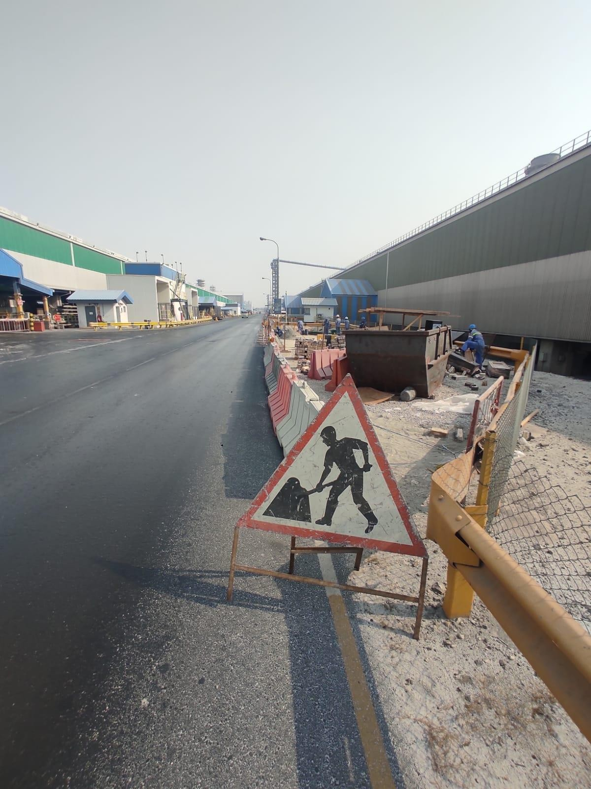

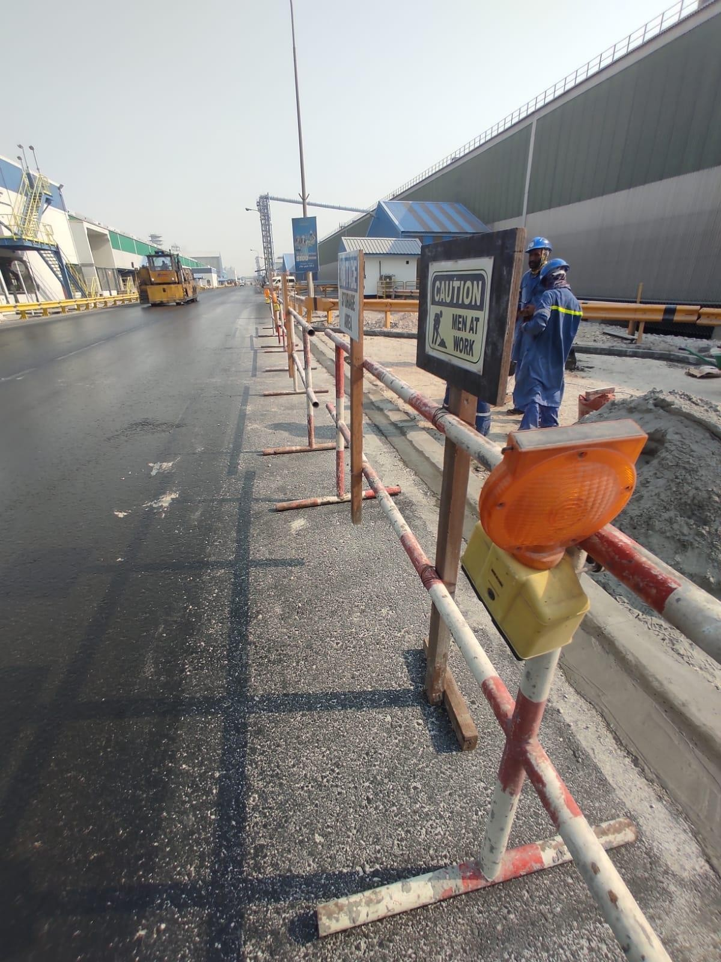

1000-0000001-9990-DC-XA-0003 Rev.00

### Next Month Safety Focus and planning

#### We have planned for a temporary rest shed at site.

# Attachments

## Monthly Site Inspection form completed

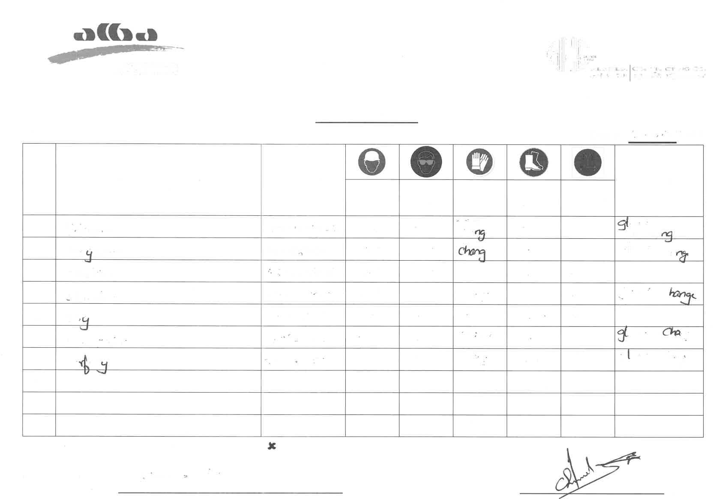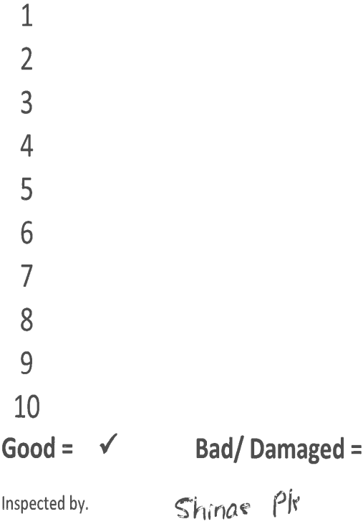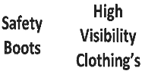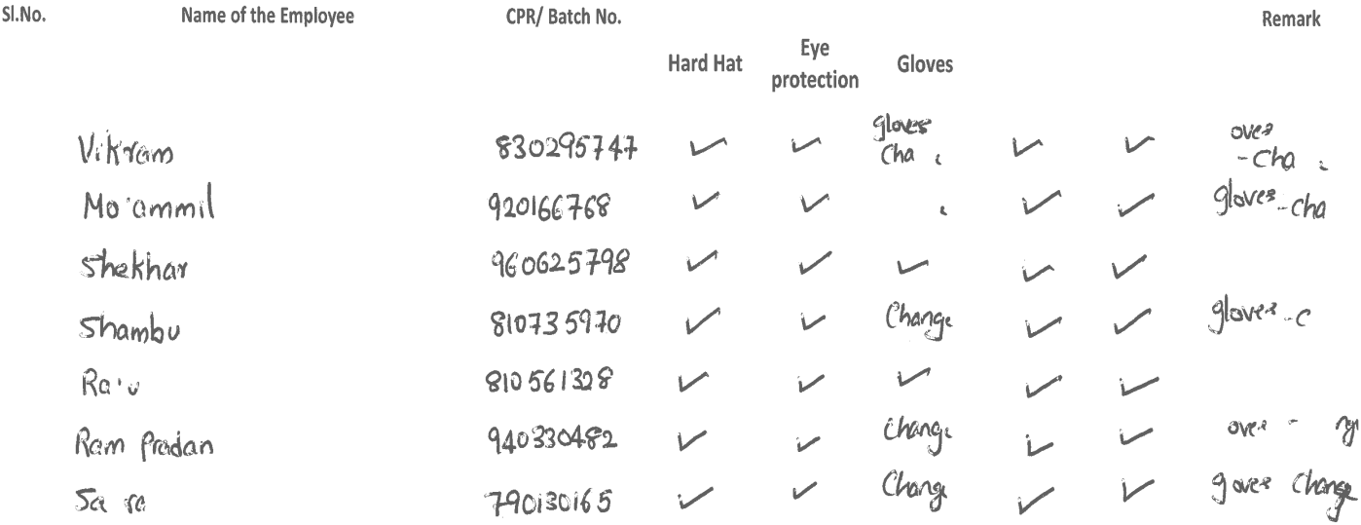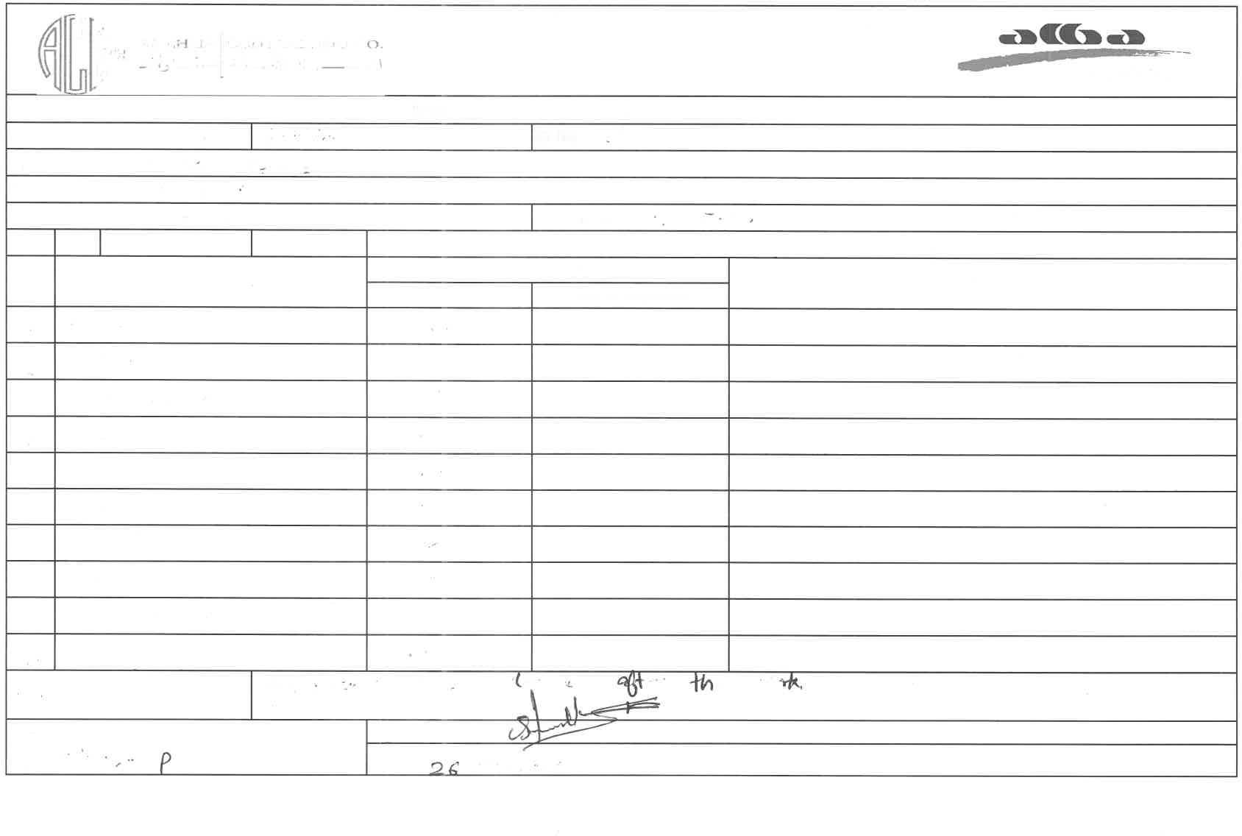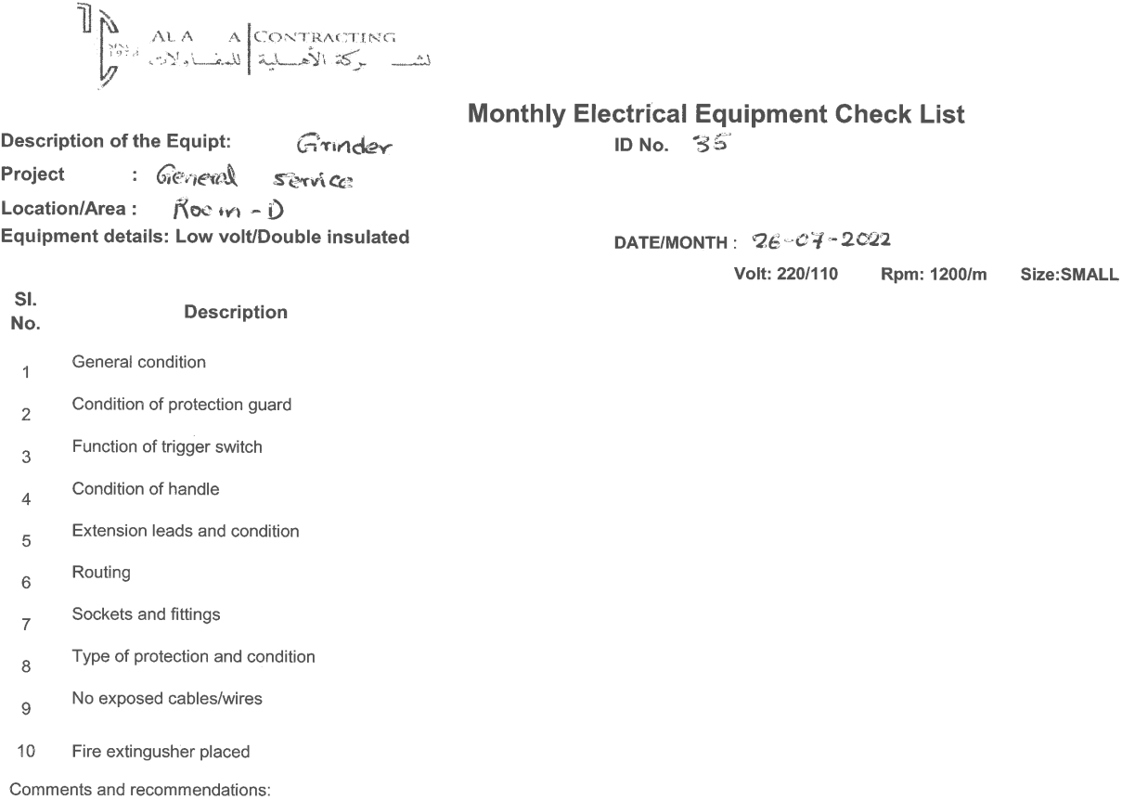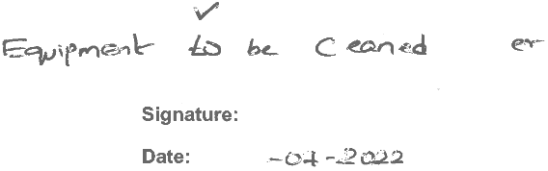

* 1. Temporary site establishment inspection completed

**Scattered bricks were stacked properly**

#### Before

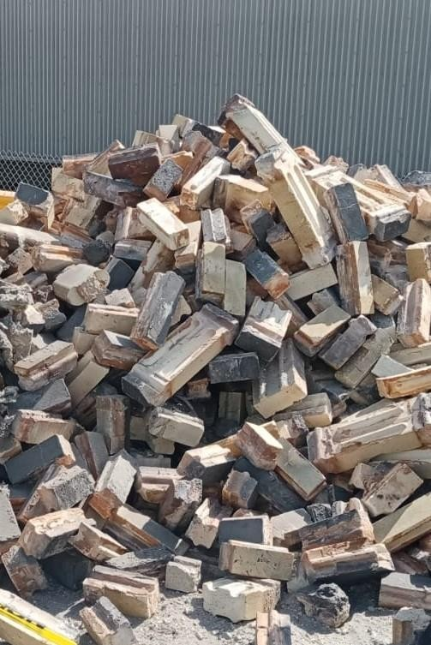

#### After

